**Output Screenshots**

* **Classes output**

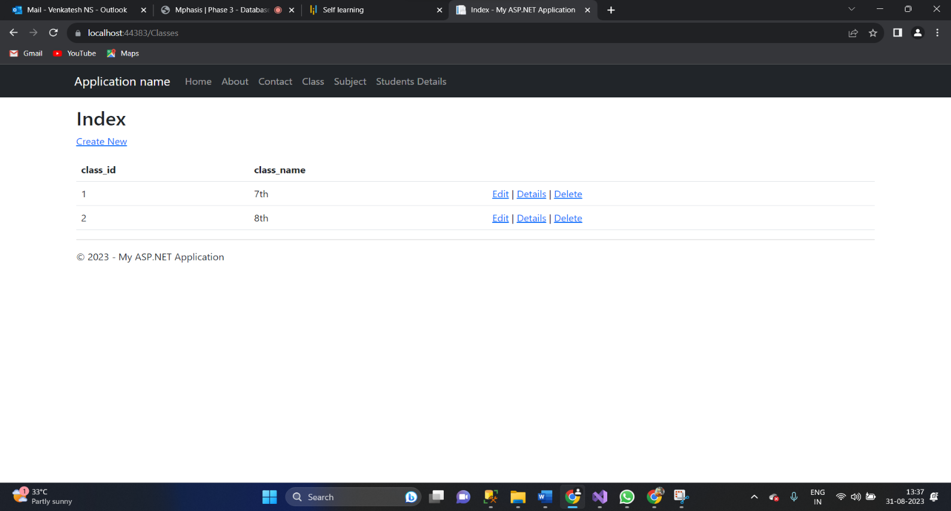

* **Subject output**

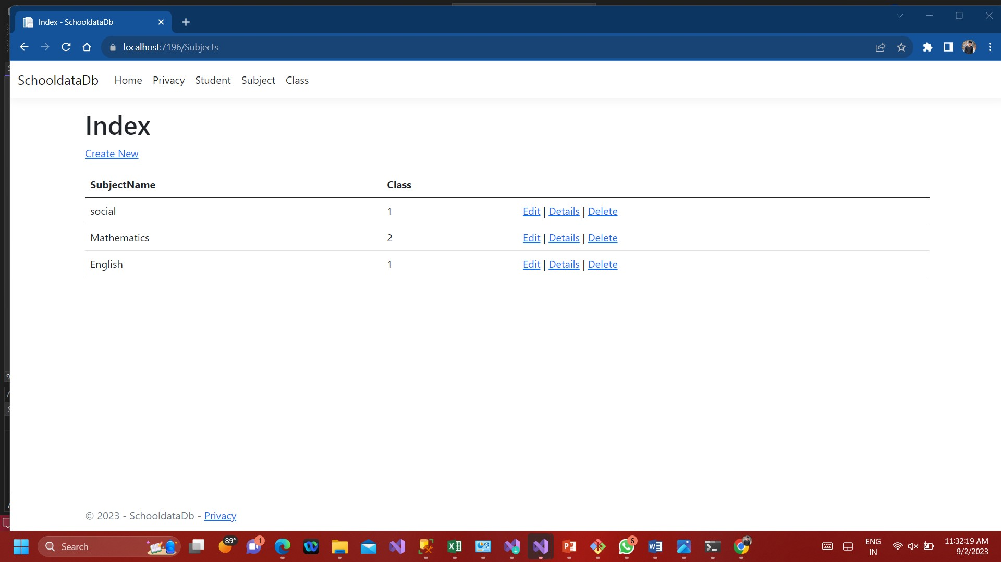

* **Student output**

